Any .Net application when compiled generate Assembly (.exe or DLL)

Assembly Contains – Manifest and IL

Some information in the assembly manifest can be modified using attributes.

We use ILDASM (Intermediate language disassembler) to peek at the assembly manifest and IL. You can also use this tool to export manifest and it to text file.

We use ILASM (Intermediate language assembler) to reconstruct an assembly from a text file that contains manifest and IL

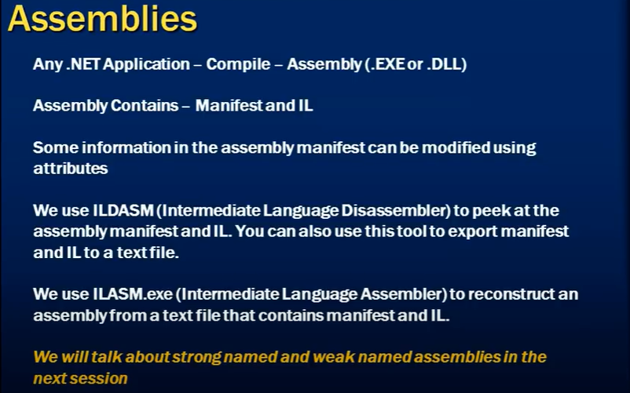

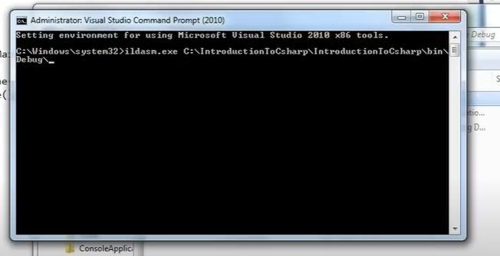

ILDASM

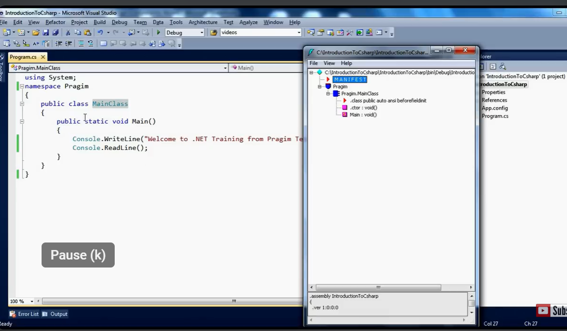

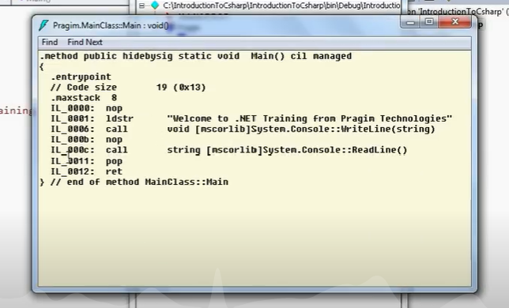

Manifest consist of metadata of your assembly. It has you Intermediate language code(IL). Sample IL code is.

